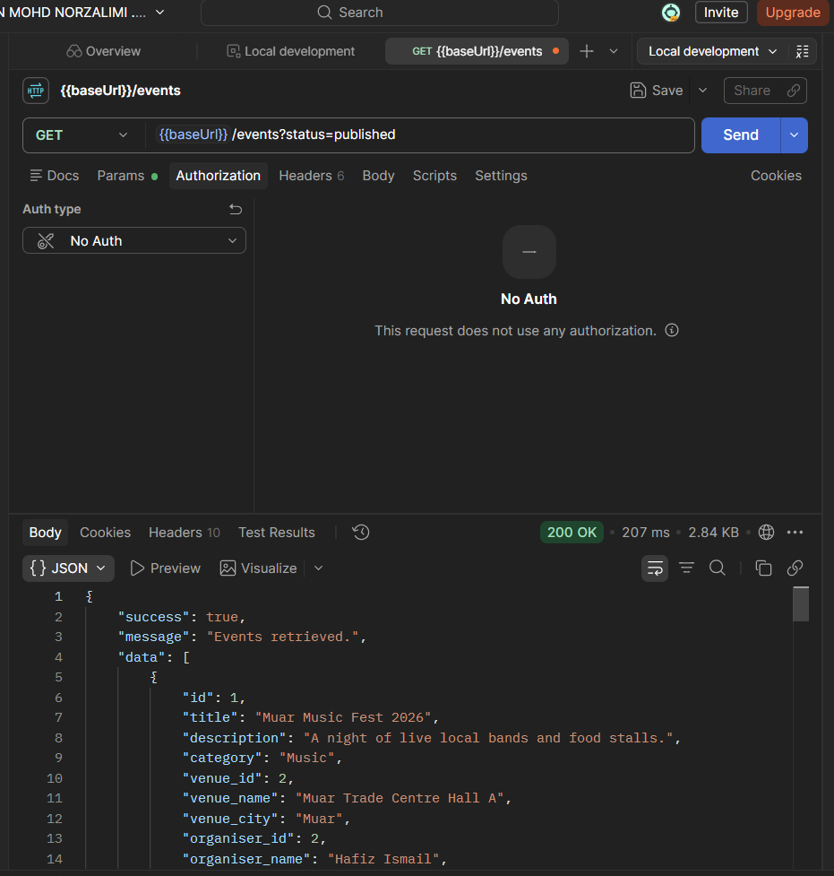
Figure 1: Public event results (200 OK)
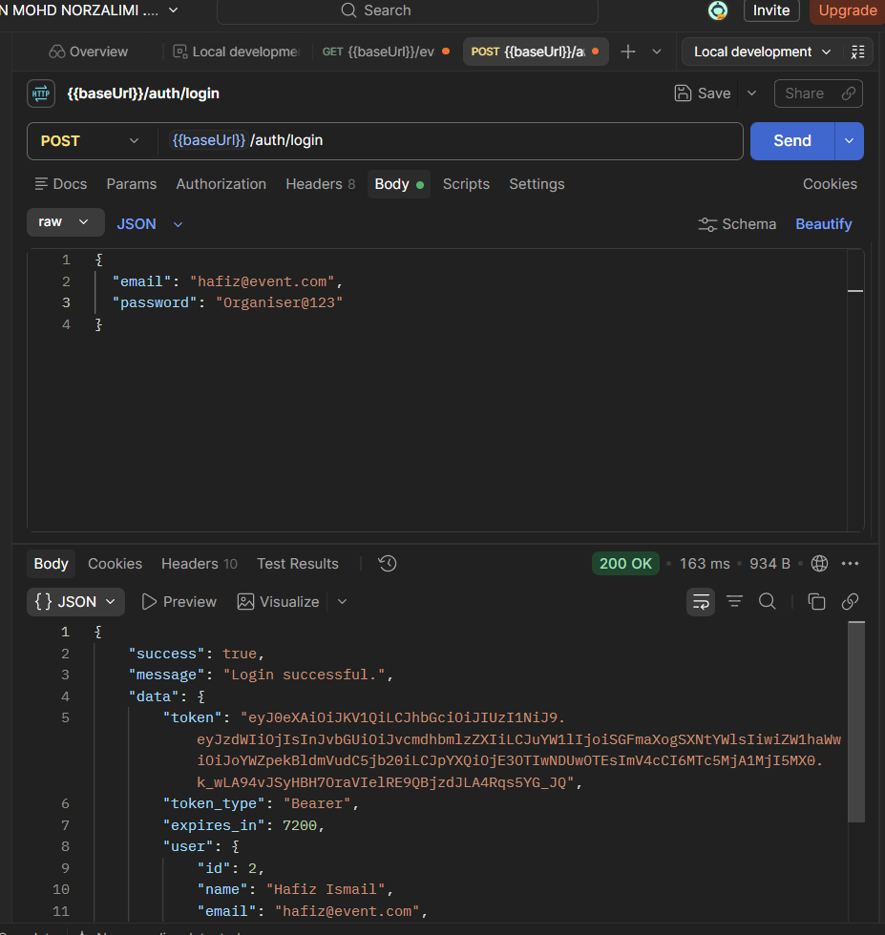
Figure 2:Organiser login (200 OK)
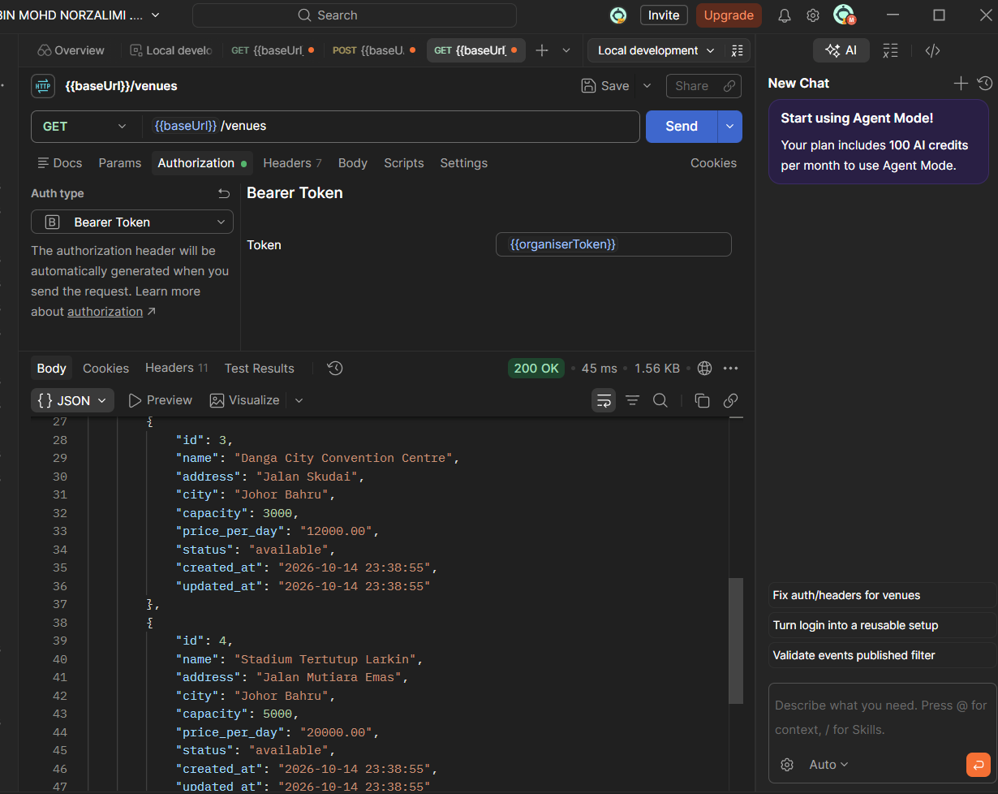
Figure 3: Get venues (200 OK)
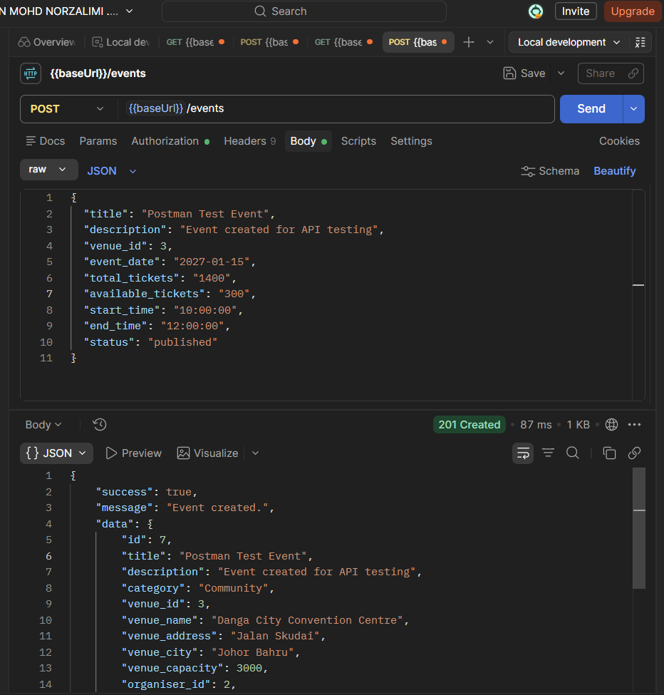
Figure 4: Create event (201 Created)
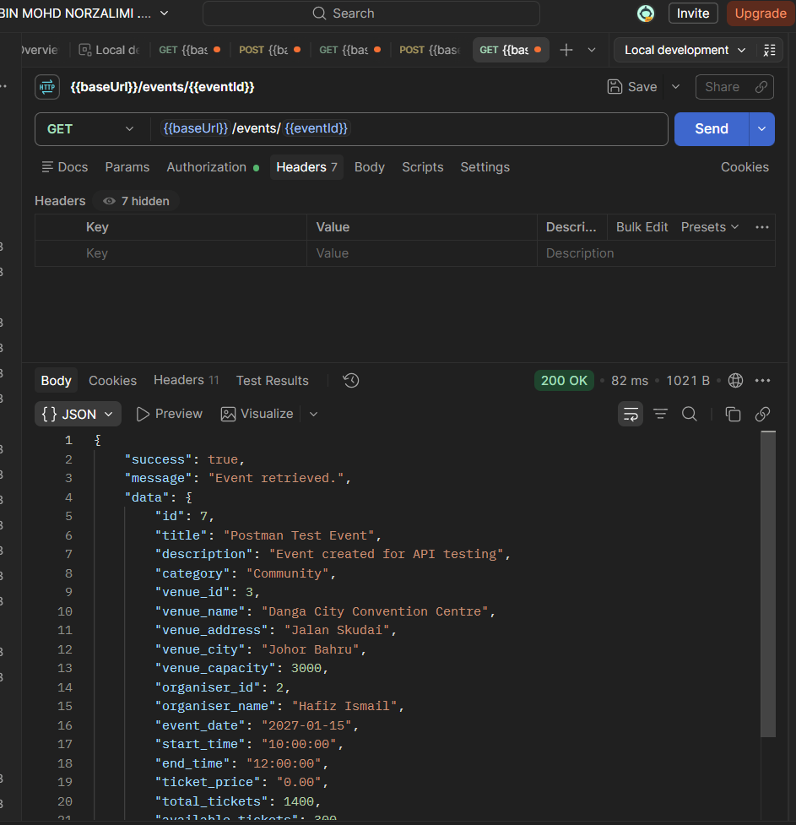
Figure 5: Get event by ID (200 OK)
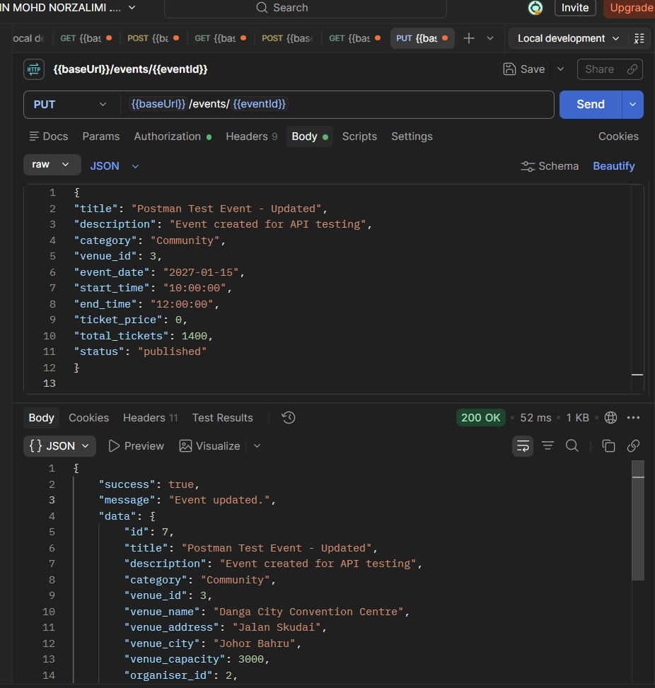
Figure 6: Update event title (200 OK)
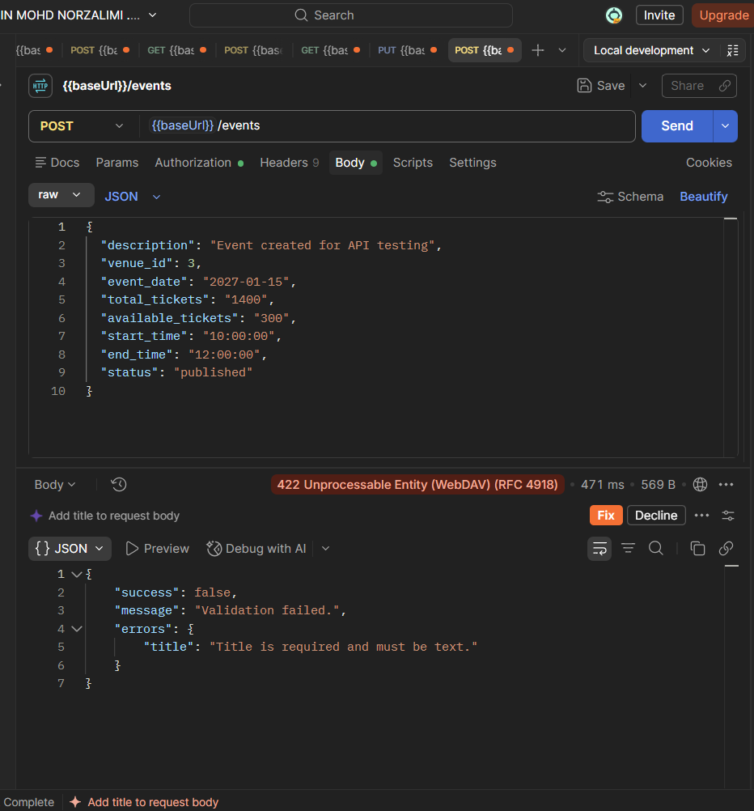
Figure 7: Missing title (422 Unprocessable entity)

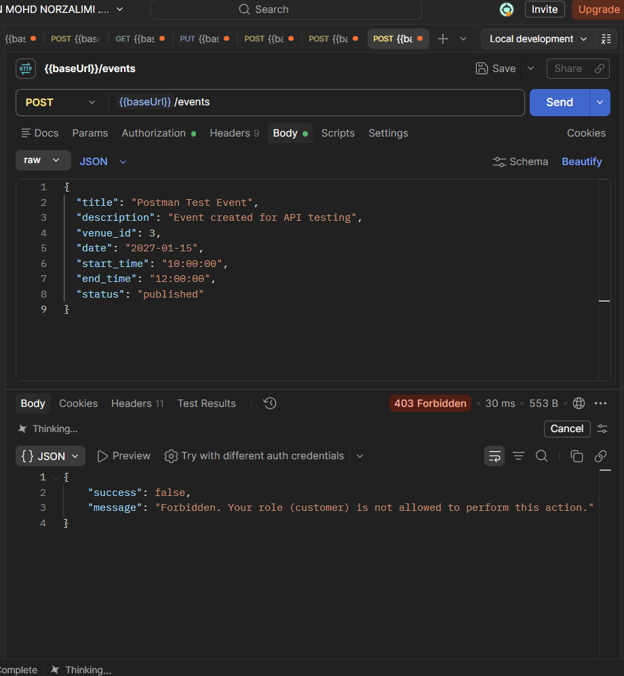
Figure 8: Customer creates event (403 forbidden)
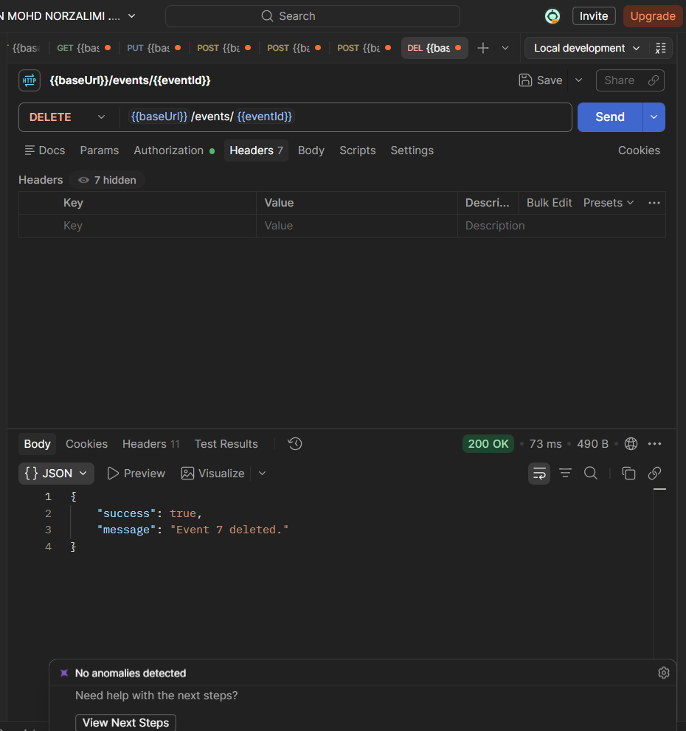
Figure 9: delete event (200 OK)

